**VNF TOSCA Template Requirements for OpenO**

1. Introduction 3

1.1 Intended Audience 4

1.2 Scope 4

1.3 Overview 4

2. VNF TOSCA Designer 4

2.1 Specifications 4

2.2 Model Design 5

2.2.1 Component Design 5

2.2.2 Relationship Type Design 6

2.2.3 Data Type Definition 6

2.2.4 Topology Design 7

2.2.5 Workflow Design 7

2.2.6 Policy Design 8

2.2.7 SFC Design 8

2.2.8 Deployment Flavor Design 8

2.2.9 Parameter Design 9

2.2.10 Artifact Design 10

2.3 Design Package 12

2.3.1 tosca.meta 12

2.3.2 Model Description Files 12

2.3.3 Workflow Description Files 12

2.3.4 Policy Description Files 13

2.3.5 Artifacts 13

2.4 Design Verification 13

2.4.1 Grammar Check 13

2.4.2 Tosca Model Verification 13

2.4.3 CSAR Package Checking 13

2.5 Design Publishing 13

2.6 Archive Management 14

2.6.1 Design Repository 14

2.6.2 Release Repository 14

2.6.3 Onboard 14

3. VNF Package 14

3.1 TOSCA-Metadata Directory 15

3.2 Definitions Directory 17

3.3 SwImages Directory 17

3.4 Check Sum List File 17

3.5 Csar Metadata File 17

4. NFV TOSCA Template 18

4.1 TOSCA Introduction 18

4.2 TOSCA Modeling Principles & Data Model 19

4.3 VNF Descriptor Template 19

4.4 EPA Requirements 21

4.5 NFV TOSCA Type Definition 24

tosca.capabilites.nfv.VirtualCompute 24

tosca.nodes.nfv.VDU.Compute 25

tosca.nodes.nfv.Cpd 29

tosca.nodes.nfv.VduCpd 31

tosca.nodes.nfv.VDU.VirtualStorage 33

tosca.artifacts.nfv.SwImage 33

4.6 vNAT Example 35

# Introduction

This reference document is the ***VNF TOSCA Template Requirements for OpenO***, which provides recommendations and standards for building VNF TOSCA templates compatible with OpenO– initial implementations of Network Cloud. It has the following features:

1. VNF TOSCA template designer supports GUI and CLI.
2. VNF TOSCA template is aligned to the newest TOSCA protocol, “Working Draft 04-Revision 06”.
3. VNF TOSCA template supports EPA features, such as NUMA, Hyper Threading, SRIOV， etc.

## Intended Audience

This document is intended for persons developing VNF TOSCA templates that will be orchestrated by OpenO.

## Scope

OpenO implementations of Network Cloud supports TOSCA Templates, also referred to as TOSCA in this document.

OpenO requires the TOSCA Templates to follow a specific format. This document provides the mandatory, recommended, and optional requirements associated with this format.

## Overview

The document includes three charters to help the VNF vendors to use the VNF model design tools and understand the VNF package structure and VNF TOSCA templates.

In the OPENO, VNF Package and VNFD template can be designed by manually or via model designer tools. VNF model designer tools can provide the GUI and CLI tools for the VNF vendor to develop the VNF Package and VNFD template.

The VNF package structure is align to the NFV TOSCA protocol, and supports CSAR

The VNFD and VNF package are all align to the NFV TOSCA protocol, which supports multiple TOSCA template yaml files, and also supports self-defined node or other extensions.

# VNF TOSCA Designer

## Specifications

Model design follows the following specifications:

TOSCA-v1.0:

http://docs.oasis-open.org/tosca/TOSCA/v1.0/TOSCA-v1.0.html

TOSCA-Simple-Profile-YAML-v1.1:

http://docs.oasis-open.org/tosca/TOSCA-Simple-Profile-YAML/v1.1/TOSCA-Simple-Profile-YAML-v1.1.html

tosca-nfv-v1.0-wd04-rev06.

## Model Design

### Component Design

Components used in service orchestration as the basic unit of NF/NS service template.

#### NF Component Design

Follows specification tosca-nfv-v1.0-wd04-rev06, defined the components in NF orchestration, including VDU.Compute、VirtualStorage、Cpd、VduCpd、VnfVirtualLinkDesc、VnfExtCpd etc. Currently, these components packaged and distributed with designer as basic components of NFV.

#### NS Component Design

Follows specification tosca-nfv-v1.0-wd04-rev06, defined the components in NS orchestration. Including Cpd、VnfVirtualLinkDesc、VNF、PNF、FP、VNFFG、NS etc. Currently, these components packaged and distributed with designer as basic components of NFV.

#### Component Nesting Design

An orchestrated NF/NS service template can be mapped to a component with the keyword “substitution_mappings”. This component can be used in the orchestration of other NS.

Nested orchestration diagram shows as follows:

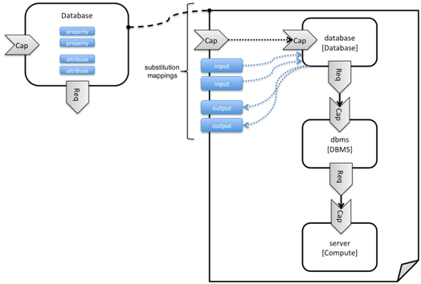 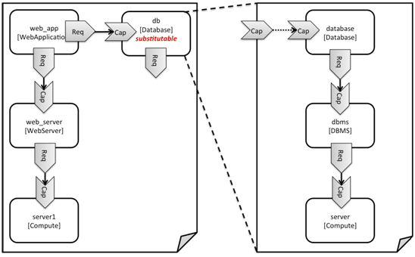

1. Requirement Mapping
2. Capability Mapping
3. Property Mapping

The input parameters in service template can be mapped to the property in component automatically.

#### Component Customizing

There are mainly two ways to customize component: Mapping and inheritance.

1. Mapping

Map an orchestrated service template to a component. For detail in 1.1.3 Component Nesting Design.

1. Inheritance

Define a customized component by inheriting a component which already existed. The new component will inherit all the content from the parent component, including: Property/Requirement/Capability etc. And also new customized attribute Property/Requirement/Capability can be added.

### Relationship Type Design

#### Basic Relationship Type

Basic relationship type defined follows the specification TOSCA-Simple-Profile-YAML-v1.1. Including DependsOn、HostedOn、ConnectsTo、AttachesTo etc. Basic relationship type was packaged and distributed with the designer.

#### NFV Relationship Type

Follows the specification tosca-nfv-v1.0-wd04-rev06 to define the NFV relationship type, Including VirtualBindsTo、VirtualLinksTo、ForwardsTo etc. NFV relationship types can be packaged and distributed with the model designer in NFV domain.

#### Customize Relationship Type

Customize relationship type was supported.

Customized relationship type can inherit with an existing relationship type.

The properties and operations of relationship can be defined. And the target node types which linked to can also be defined.

### Data Type Definition

#### Basic Data Type

The system provides the definition of basic data type. Including: string、integer、float、boolean、timestamp. Follow the specification TOSCA-Simple-Profile-YAML-v1.1.

List and map are supported.

#### NFV Data Type

Data type of NFV domain defined according to tosca-nfv-v1.0-wd04-rev06. Including L2AddressData、L3AddressData、AddressData、VirtualNetworkInterfaceRequirements、ConnectivityType、RequestedAdditionalCapability、VirtualMemory、VirtualCpu、VirtualCpuPinning etc.

NFV data type can be packaged and distributed with the model designer in NFV domain.

#### Customize Data Type

Support to defining custom data type with the basic data type and list/map.

Support nesting of custom data types, that is, defining new data types with existing custom data types.

### Topology Design

#### Node Design

To design the contents of the service template components and TOPO structure through the component drag and drop.

1. NF Node Design

Drag a component instance from the NF component library to the topology view.

A component represents an NF logical module of the service. For example, VDU.Compute represents the calculation module, Cpd represents virtual port, VirtualStorage represents virtual storage unit.

1. NS Node Design

Drag a component instance from the NS component library to the topology view.

A component represents an NS logical module of the service. For example, VNF represents virtualized network function module, PNF represents physical network module (eg. physical network element).

#### Relationship Design

Drag a connection from one component to another to represent the relationship between the components.

The type of relationship is represented by the type of connection, for example: DependsOn、HostedOn、ConnectsTo、VirtualBindsTo、VirtualLinksTo etc.

#### Property Orchestration

You can set properties for components and relationships for use by an instantiated deployment.

### Workflow Design

#### BNPM4TOSCA Workflow Designer

Embed BNPM4TOSCA workflow designer is provided, you can design BNPM workflow.

Workflow design interface shows as follows:

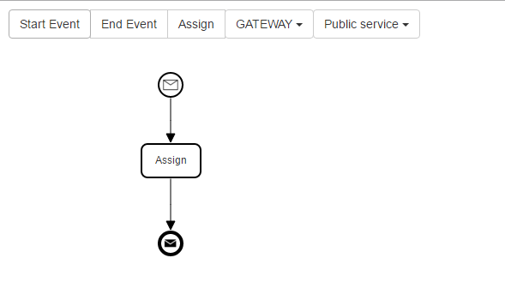

#### Service Template Operation Design

Service template operations include: create, start, stop, delete, etc. You can define the operations of the service template and associated operations with specified workflows.

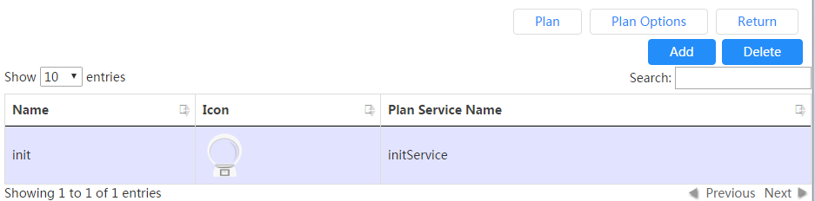

### Policy Design

Embed Drools-based policy designer is provided.

### SFC Design

Provide a SFC graphical design interface, support to design business service chain.

### Deployment Flavor Design

Support to design the deployment flavor of a VDU, shows as follows:

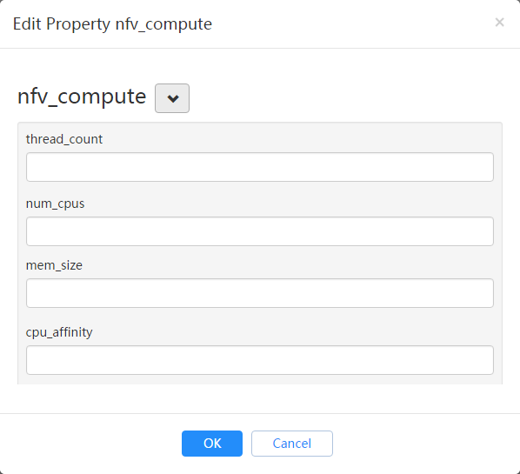

Supports to design the scale parameters of a VDU, shows as follows:

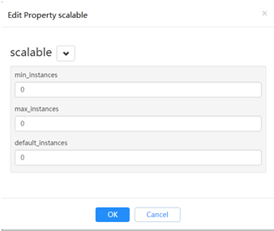

### Parameter Design

If an Entity property value is not determined at the design time (including: node template, relationship template, etc), and need to entered at the deployment phase dynamically. So the values need to abstract as the service template input parameters.

#### Parameter Definition

Support input parameter definition, show as follow:

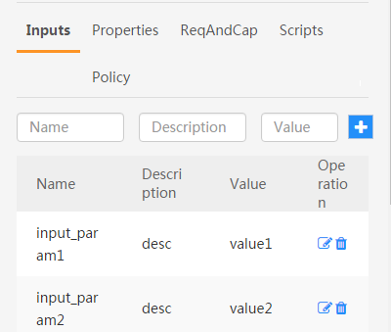

#### Parameter Mapping

Map input parameters to properties of nodes or relationships with the “get_input” function, according to the TOSCA-Simple-Profile-YAML-v1.1 specification.

Support the mapping of simple parameters, complex parameters, and properties of a complex parameter.

### Artifact Design

Artifact mainly includes scripts, images, software packages and other materials which may be used in the deploy phase.

#### Script Artifacts

The script files are typically bound to the service template and uploaded to the ‘Scripts’ directory of the service template.

At the same time, you can create an artifact to associate the script file with a specific node.

#### Image Artifacts

Images can be bound to a service template and uploaded to the ‘SoftwareImages’ directory. Or they can be uploaded to a separate images server.

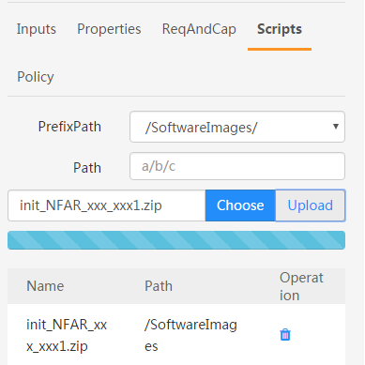

At the same time, you can create an artifact to associate the image file with a specific node. Show as follow:

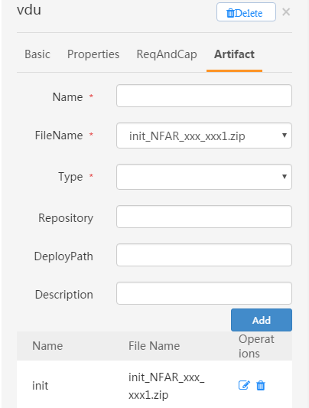

#### Software package artifacts

The software package is typically the software version provided by the device vendor. Software packages can be bound to a service template or they can be uploaded to a separate software packages server.

At the same time, you can create an artifact to associate the software package with a specific node.

## Design Package

Following the TOSCA-Simple-Profile-YAML-v1.1 specification, the design output is packaged in the CSAR (TOSCA Cloud Service Archive) format.

Design output includes: model description file, workflow description file, policy description file, tosca.meta, manifest file, artifact file (including: scripts, images, software packages, etc.) and so on.

Suggested package structure is as follows:

|  |  |  |
| --- | --- | --- |
| Folder Name | Required | Description |
| TOSCA-Metadata | Yes | Used to define the basic properties of the VNF package, and the Entry-Definitions file. |
| Definitions | Yes | Yaml or xml format TOSCA definition file, the document on the artifact file reference is relative to the CSAR package root path. |
| Plans | No | VNF lifecycle implementation of the workflow. |
| Policies | No | Policy description files. |
| Scripts | No | Script files |
| SoftwareImages | No | Host software image files |
| AppSoftwares | No | Application software files |
|  |  |  |

### tosca.meta

tosca.meta defined as a basic information of service template, it is a manifest file.

Tosca.meta example:

|  |
| --- |
| TOSCA-Meta-File-Version: 1.0  CSAR-Version: 1.1  Created-By: OASIS TOSCA TC  Entry-Definitions: definitions/tosca_elk.yaml |

### Model Description Files

The model description files includes: component definition files, relationship type definition files, data type definition files, TOPO description files and so on.

The model description files will be packaged into the ‘Definitions’ directory of the CSAR package.

### Workflow Description Files

The Workflow description files is the output files of the Workflow designer.

The workflow description files will be packaged into the ‘Plans’ directory of the CSAR package.

### Policy Description Files

Policy description files is the output files of the Policy Designer.

The policy description files will be packaged into the ‘Policies’ directory of the CSAR package.

### Artifacts

#### Script Artifacts

Script files are usually packaged directly into the ‘Scripts’ directory of the CSAR package.

#### Image Artifacts

The images bound to the service template are packaged directly into the ‘SoftwareImages’ directory of the CSAR package.

#### Software Package Artifacts

The software packages bound to the service template are packaged directly into the ‘AppSoftwares’ directory of the CSAR package.

## Design Verification

### Grammar Check

Yaml/xml syntax check, tosca syntax check, data type validation and so on.

### Tosca Model Verification

Type check, relationship check, requirement check, artifact check, constraint check, etc.

### CSAR Package Checking

CSAR packet structure verification and packet integrity checking.

## Design Publishing

CSAR package can be published to the catalog for the instantiation use, after it has been verified.

## Archive Management

### Design Repository

In the design phase, the service template is stored in the design repository.

The service templates in the design repository can be modified at any time.

### Release Repository

After the service template design is completed, you can publish it to the release repository through a publish process.

And, the service template can be instantiated and deployed only after it has been published.

The service templates in the release repository cannot be modified again.

### Onboard

Before the deployment of the service template, you need to perform the Onboard operation.

The main work of the onboard operation includes:

1. Upload the image and package to VNFM and VIM.
2. Distribute the workflow description file to the workflow execution engine.
3. Distribute the policy description file to the policy execution engine.

# VNF Package

This section defines VNF package as well as its overall structure. A VNF package shall be a CSAR(Cloud Service Archive), which is a zip file in compliance to TOSCA, including at least one csar.meta file, one checksum.lst file, one directory for TOSCA-Metadata, one directory for *Definitions* and one directory for images. The directories for *Plans*, *scripts*, xml files etc. are optional.

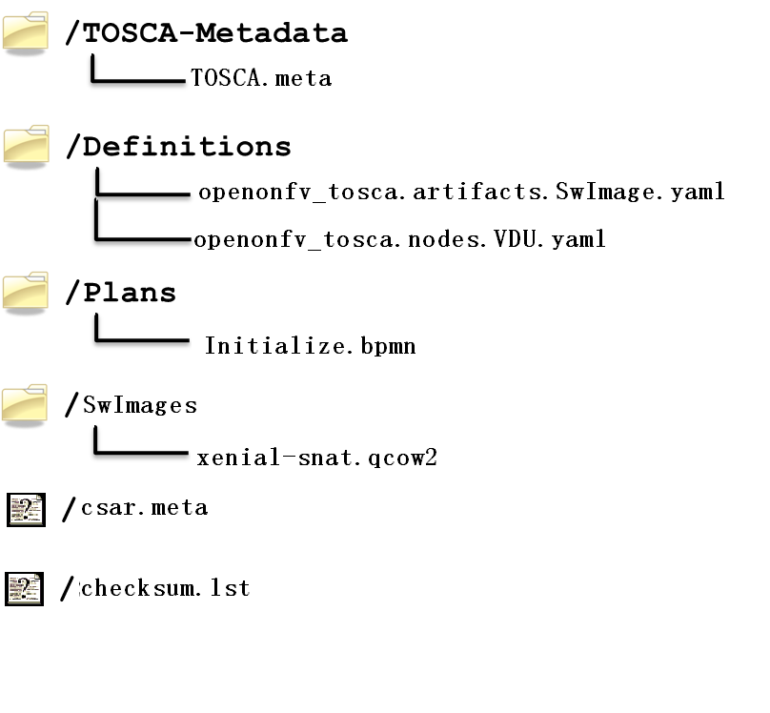

## TOSCA-Metadata Directory

This directory contains TOSCA.metadata file. A TOSCA meta file consists of name/value pairs. The name-part of a name/value pair is followed by a colon, followed by a blank, followed by the value-part of the name/value pair. The name MUST NOT contain a colon. Values that represent binary data MUST be base64 encoded. Values that extend beyond one line can be spread over multiple lines if each subsequent line starts with at least one space. Such spaces are then collapsed when the value string is read.

1. <name>: <value>

Each name/value pair is in a separate line. A list of related name/value pairs, i.e. a list of consecutive name/value pairs describing a particular file in a CSAR, is called a *block*. Blocks are separated by an empty line. The first block, called *block_0*, is metadata about the CSAR itself. All other blocks represent metadata of files in the CSAR.

The structure of block_0 in the TOSCA meta file is as follows:

1. TOSCA-Meta-File-Version: digit.digit
2. CSAR-Version: digit.digit
3. Created-By: string
4. Entry-Definitions: string ?

The name/value pairs are as follows:

* TOSCA-Meta-File-Version: This is the version number of the TOSCA meta file format. The value MUST be “1.0” in the current version of the TOSCA specification.
* CSAR-Version: This is the version number of the CSAR specification. The value MUST be “1.0” in the current version of the TOSCA specification.
* Created-By: The person or vendor, respectively, who created the CSAR.
* Entry-Definitions: This OPTIONAL name/value pair references a TOSCA Definitions file from the Definitions directory of the CSAR that SHOULD be used as entry point for processing the contents of the CSAR.   
  Note, that a CSAR may contain multiple Definitions files. One reason for this is completeness, e.g. a Service Template defined in one of the Definitions files could refer to Node Types defined in another Definitions file that might be included in the Definitions directory to avoid importing it from external locations. The Entry-Definitions name/value pair is a hint to allow optimized processing of the set of files in the Definitions directory.

The first line of a block (other than block_0) MUST be a name/value pair that has the name “Name” and the value of which is the path-name of the file described. The second line MUST be a name/value pair that has the name “Content-Type” describing the type of the file described; the format is that of a MIME type with type/subtype structure. The other name/value pairs that consecutively follow are file-type specific.

1. Name: <path-name_1>
2. Content-Type: type_1/subtype_1
3. <name_11>: <value_11>
4. <name_12>: <value_12>
5. ...
6. <name_1n>: <value_1n>
7. ...
9. Name: <path-name_k>
10. Content-Type: type_k/subtype_k
11. <name_k1>: <value_k1>
12. <name_k2>: <value_k2>
13. ...
14. <name_km>: <value_km>

The name/value pairs are as follows:

* Name: The pathname or pathname pattern of the file(s) or resources described within the actual CSAR.   
  Note, that the file located at this location MAY basically contain a reference to an external file. Such a reference is given by a URI that is of one of the URL schemes “file”, “http”, or “https”.
* Content-Type: The type of the file described. This type is a MIME type complying with the type/subtype structure. Vendor defined subtypes SHOULD start as usual with the string “vnd.”.

Note that later directives override earlier directives. This allows for specifying global default directives that can be specialized by later directories in the TOSCA meta file.

## Definitions Directory

This directory contains all TOSCA yaml files including definitions of Node, Relationship, Capabilities, Artifacts, and Requirements etc. as components of VNF package.

## SwImages Directory

Image files of VNF are stored in this directory.

## Check Sum List File

The file of checksum.lst records the MD5(RFC 1321) value of each file when building csar package in order to double check whether those files were destroyed when users unzip the zip file. A checksum.lst file consists of name/value pairs. The name-part of a name/value pair is followed by a colon, followed by a blank, followed by the value-part of the name/value pair. Here is an example as follows.

Definitions/openovnf__vOpenNAT.yaml:00a5d15b350b90b75f11c33d4c7a0218

Swimages/xenial-snat.qcow2:481f62ed11aa6e240482974feb1dcab6

## Csar Metadata File

A VNF package, which is a csar zip file shall contain one csar.meta file. A csar Meta file consists of name/value pairs. The name-part of a name/value pair is followed by a colon, followed by a blank, followed by the value-part of the name/value pair. The name MUST NOT contain a colon. Values that represent binary data MUST be base64 encoded. Values that extend beyond one line can be spread over multiple lines if each subsequent line starts with at least one space. Such spaces are then collapsed when the value string is read.

<name>: <value>

Generally, this file includes basic information about this VNF package including type, version and provider, etc. Here is an example as follows.

1. Type:NFAR
2. Version:1.0.0

Provider: ZTE

# NFV TOSCA Template

TOSCA templates supported by OPENO must follow the requirements enumerated in this section.

## TOSCA Introduction

TOSCA defines a Meta model for defining IT services. This Meta model defines both the structure of a service as well as how to manage it. A Topology Template (also referred to as the topology model of a service) defines the structure of a service. Plans define the process models that are used to create and terminate a service as well as to manage a service during its whole lifetime. The major elements defining a service are depicted in Figure 1.

A Topology Template consists of a set of Node Templates and Relationship Templates that together define the topology model of a service as a (not necessarily connected) directed graph. A node in this graph is represented by a *Node Template*. A Node Template specifies the occurrence of a Node Type as a component of a service. A *Node Type* defines the properties of such a component (via *Node Type Properties*) and the operations (via *Interfaces*) available to manipulate the component. Node Types are defined separately for reuse purposes and a Node Template references a Node Type and adds usage constraints, such as how many times the component can occur.

Reuse and Derivation of TOSCA Definitions



Figure 1: Structural Elements of a Service Template and their Relations

## TOSCA Modeling Principles & Data Model

This section describing TOSCA modeling principles and data model for NFV, which shall be based on [TOSCA-1.0] and [TOSCA-Simple-Profile-YAML V1.0], or new type based on ETSI NFV requirements, etc.

## VNF Descriptor Template

The VNF Descriptor (VNFD) describes the topology of the VNF by means of ETSI NFV IFA011 [IFA011] terms such as VDUs, Connection Points, Virtual Links, External Connection Points, Scaling Aspects, Instantiation Levels and Deployment Flavours.

The VNFD (VNF Descriptor) is read by both the NFVO and the VNFM. It represents the contract & interface of a VNF and ensures the interoperability across the NFV functional blocks.

The main parts of the VNFD are the following:

* VNF topology: it is modeled in a cloud agnostic way using virtualized containers and their connectivity. Virtual Deployment Units (VDU) describe the capabilities of the virtualized containers, such as virtual CPU, RAM, disks; their connectivity is modeled with VDU Connection Point Descriptors (VduCpd), Virtual Link Descriptors (Vld) and VNF External Connection Point Descriptors (VnfExternalCpd);
* VNF deployment aspects: they are described in one or more deployment flavours, including instantiation levels, supported LCM operations, VNF LCM operation configuration parameters, placement constraints (affinity / antiaffinity), minimum and maximum VDU instance numbers, and scaling aspect for horizontal scaling.

The following table defines the TOSCA Type “derived from” values that SHALL be used when using the TOSCA Simple Profile for NFV version 1.0 specification [TOSCA-Simple-Profile-NFV-v1.0] for NFV VNFD.

|  |  |  |
| --- | --- | --- |
| **ETSI NFV Element**  **[IFA011]** | **TOSCA VNFD**  **[TOSCA-Simple-Profile-NFV-v1.0]** | **Derived from** |
| VNF | tosca.nodes.nfv.VNF | tosca.nodes.Root |
| VDU | tosca.nodes.nfv.VDU | tosca.nodes.Root |
| Cpd (Connection Point) | tosca.nodes.nfv.Cpd | tosca.nodes.Root |
| VduCpd (internal connection point) | tosca.nodes.nfv.VduCpd | tosca.nodes.nfv.Cpd |
| VnfVirtualLinkDesc (Virtual Link) | tosca.nodes.nfv.VnfVirtualLinkDesc | tosca.nodes.Root |
| VnfExtCpd (External Connection Point) | tosca.nodes.nfv.VnfExtCpd | tosca.nodes.Root |
| Virtual Storage |  |  |
| Virtual Compute |  |  |
| Software Image |  |  |
| Deployment Flavour |  |  |
| Scaling Aspect |  |  |
| Element Group |  |  |
| Instantiation Level |  |  |

|  |  |
| --- | --- |
| |  | | --- | | tosca_definitions_version: tosca_simple_yaml_1_0  description: VNFD TOSCA file demo  imports:  - TOSCA_definition_nfv_1_0.yaml  - TOSCA_definition_nfv_ext_1_0.yaml  **node_types:  tosca.nodes.nfv.VNF.vOpenNAT:  derived_from:** tosca.nodes.nfv.VNF  **requirements:** - **sriov_plane:  capability:** tosca.capabilities.nfv.VirtualLinkable  **node:** tosca.nodes.nfv.VnfVirtualLinkDesc  **relationship:** tosca.relationships.nfv.VirtualLinksTo | |
|  |

## EPA Requirements

1. SR-IOV Passthrought

Definitions of SRIOV_Port are necessary if VDU supports SR-IOV. Here is an example.

|  |
| --- |
| node_templates:  vdu_vNat:  SRIOV_Port:  attributes:  tosca_name: SRIOV_Port  properties:  virtual_network_interface_requirements:  - name: sriov  support_mandatory: false  description: sriov  requirement:  SRIOV: true  role: root  description: sriov port  layer_protocol: ipv4  requirements:  - virtual_binding:  capability: virtual_binding  node: vdu_vNat  relationship:  type: tosca.relationships.nfv.VirtualBindsTo  - virtual_link:  node: tosca.nodes.Root  type: tosca.nodes.nfv.VduCpd  substitution_mappings:  requirements:  sriov_plane:  - SRIOV_Port  - virtual_link  node_type: tosca.nodes.nfv.VNF.vOpenNAT |

1. Hugepages

Definitions of mem_page_size as one property shall be added to Properties and set the value to large if one VDU node supports huagepages. Here is an example.

|  |
| --- |
| node_templates:  vdu_vNat:  Hugepages:  attributes:  tosca_name: Huge_pages_demo  properties:  mem_page_size:large |
|  |

1. NUMA (CPU/Mem)

Likewise, we shall add definitions of numa to requested_additional_capabilities if we wand VUD nodes to support NUMA. Here is an example.

|  |
| --- |
| topology_template:  node_templates:  vdu_vNat:  capabilities:  virtual_compute:  properties:  virtual_memory:  numa_enabled: true  virtual_mem_size: 2 GB  requested_additional_capabilities:  numa:  support_mandatory: true  requested_additional_capability_name: numa  target_performance_parameters:  hw:numa_nodes: "2"  hw:numa_cpus.0: "0,1"  hw:numa_mem.0: "1024"  hw:numa_cpus.1: "2,3,4,5"  hw:numa_mem.1: "1024" |

1. Hyper-Theading

Definitions of Hyper-Theading are necessary as one of requested_additional_capabilities of one VUD node if that node supports Hyper-Theading. Here is an example.

|  |
| --- |
| topology_template:  node_templates:  vdu_vNat:  capabilities:  virtual_compute:  properties:  virtual_memory:  numa_enabled: true  virtual_mem_size: 2 GB  requested_additional_capabilities:  hyper_threading:  support_mandatory: true  requested_additional_capability_name: hyper_threading  target_performance_parameters:  hw:cpu_sockets : "2"  hw:cpu_threads : "2"  hw:cpu_cores : "2"  hw:cpu_threads_policy: "isolate" |

1. OVS+DPDK

Definitions of ovs_dpdk are necessary as one of requested_additional_capabilities of one VUD node if that node supports dpdk. Here is an example.

|  |
| --- |
| topology_template:  node_templates:  vdu_vNat:  capabilities:  virtual_compute:  properties:  virtual_memory:  numa_enabled: true  virtual_mem_size: 2 GB  requested_additional_capabilities:  ovs_dpdk:  support_mandatory: true  requested_additional_capability_name: ovs_dpdk  target_performance_parameters:  sw:ovs_dpdk: "true" |

## NFV TOSCA Type Definition

### tosca.capabilites.nfv.VirtualCompute

|  |  |
| --- | --- |
| **Shorthand Name** | VirtualCompute |
| **Type Qualified Name** | tosca: VirtualCompute |
| **Type URI** | tosca.capabilities.nfv.VirtualCompute |
| **derived from** | tosca.nodes.Root |

#### Properties

| Name | Required | Type | Constraints | Description |
| --- | --- | --- | --- | --- |
| request_additional_capabilities | No | tosca.datatypes.nfv.RequestedAdditionalCapability |  | Describes additional capability for a particular VDU. |
| virtual_memory | yes | tosca.datatypes.nfv.VirtualMemory |  | Describes virtual memory of the virtualized compute |
| virtual_cpu | yes | tosca.datatypes.nfv.VirtualCpu |  | Describes virtual CPU(s) of the virtualized compute. |
|  |  |  |  |  |
| name | yes |  |  |  |

#### Definition

|  |
| --- |
| tosca.capabilities.nfv.VirtualCompute:  derived_from: tosca.capabilities.Root  properties:  requested_additional_capabilities:  type: map  entry_schema:  type: tosca.datatypes.nfv.RequestedAdditionalCapability  required: false  virtual_memory:  type: tosca.datatypes.nfv.VirtualMemory  required: true  virtual_cpu:  type: tosca.datatypes.nfv.VirtualCpu  required: true |

### tosca.nodes.nfv.VDU.Compute

The NFV Virtualization Deployment Unit (VDU) compute node type represents a VDU entity which it describes the deployment and operational behavior of a VNF component (VNFC), as defined by **[ETSI NFV IFA011].**

|  |  |
| --- | --- |
| Shorthand Name | VDU.Compute |
| Type Qualified Name | tosca:VDU.Compute |
| Type URI | tosca.nodes.nfv.VDU.Compute |
| derived_from | tosca.nodes.Compute |

#### Properties

| Name | Required | Type | Constraints | Description |
| --- | --- | --- | --- | --- |
| name | yes | string |  | Human readable name of the Vdu |
| description | yes | string |  | Human readable description of the Vdu |
| boot_order | no | list of string |  | The key indicates the boot index (lowest index defines highest boot priority). The Value references a descriptor from which a valid boot device is created e.g. VirtualStorageDescriptor from which a VirtualStorage instance is created.  If no boot order is defined the default boot order defined in the VIM or NFVI shall be used. |
| nfvi_constraints | no | list of string |  | Describes constraints on the NFVI for the VNFC instance(s) created from this Vdu. For example, aspects of a secure hosting environment for the VNFC instance that involve additional entities or processes. More software images can be attached to the virtualization container using virtual_storage. |
| configurable_properties | yes | map of tosca.datatypes.nfv.VnfcConfigurableProperties |  | Describes the configurable properties of all VNFC instances based on this VDU. |

#### Attributes

None

#### Requirements

| Name | Required | Type | Constraints | Description |
| --- | --- | --- | --- | --- |
| virtual_storage | no | tosca.nodes.nfv.VDU.VirtualStorage |  | Describes storage requirements for a virtual_storage instance attached to the virtualization container created from virtual_compute defined for this vdu |

#### Capabilities

| Name | Type | Constraints | Description |
| --- | --- | --- | --- |
| virtual_compute | tosca.capabilities.nfv.VirtualCompute |  | Describes virtual compute resources capabilities. |
| monitoring_parameter | tosca.capabilities.nfv.Metric | None | Monitoring parameter, which can be tracked for a VNFC based on this VDU  Examples include: memory-consumption, CPU-utilisation, bandwidth-consumption, VNFC downtime, etc. |
| Virtual_binding | tosca.capabilities.nfv.VirtualBindable  editor note: need to create a capability type |  | Defines ability of VirtualBindable |

#### Definition

|  |
| --- |
| tosca.nodes.nfv.VDU.Compute:  derived_from: tosca.nodes.Compute  properties:  name:  type: string  required: true  description:  type: string  required: true  boot_order:  type: list # explicit index (boot index) not necessary, contrary to IFA011  entry_schema:  type: string  required: false  nfvi_constraints:  type: list  entry_schema:  type: string  required: false  configurable_properties:  type: map  entry_schema:  type: tosca.datatypes.nfv.VnfcConfigurableProperties  required: true  attributes:  private_address:  status: deprecated  public_address:  status: deprecated  networks:  status: deprecated  ports:  status: deprecated  capabilities:  virtual_compute:  type: tosca.capabilities.nfv.VirtualCompute  virtual_binding:  type: tosca.capabilities.nfv.VirtualBindable  #monitoring_parameter:  # modeled as ad hoc (named) capabilities in VDU node template  # for example:  #capabilities:  # cpu_load: tosca.capabilities.nfv.Metric  # memory_usage: tosca.capabilities.nfv.Metric  host: #Editor note: FFS. How this capabilities should be used in NFV Profile  type: tosca.capabilities.Container  valid_source_types: [tosca.nodes.SoftwareComponent]  occurrences: [0,UNBOUNDED]  endpoint:  occurrences: [0,0]  os:  occurrences: [0,0]  scalable: #Editor note: FFS. How this capabilities should be used in NFV Profile  type: tosca.capabilities.Scalable  binding:  occurrences: [0,UNBOUND]  requirements:  - virtual_storage:  capability: tosca.capabilities.nfv.VirtualStorage  relationship: tosca.relationships.nfv.VDU.AttachedTo  node: tosca.nodes.nfv.VDU.VirtualStorage  occurences: [ 0, UNBOUNDED ]  - local_storage: #For NFV Profile, this requirement is deprecated.  occurrences: [0,0]  artifacts:  - sw_image:  file:  type: tosca.artifacts.nfv.SwImage |

#### Artifact

| Name | Required | Type | Constraints | Description |
| --- | --- | --- | --- | --- |
| SwImage | Yes | tosca.artifacts.nfv.SwImage |  | Describes the software image which is directly loaded on the virtualization container realizing this virtual storage. |

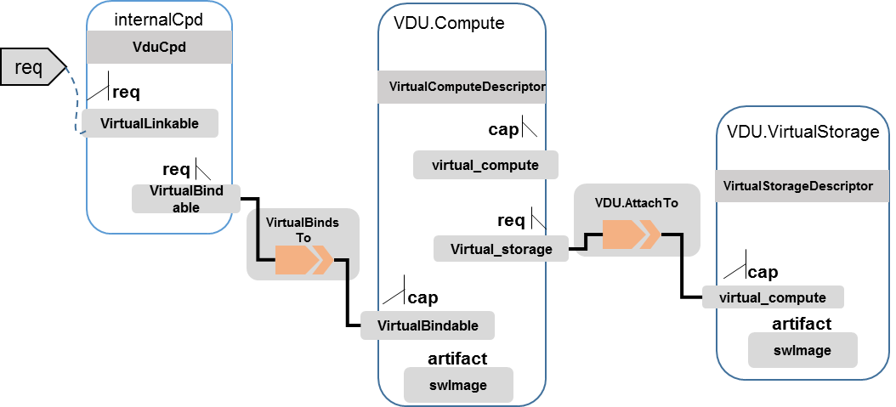

### tosca.nodes.nfv.Cpd

The TOSCA Cpd node represents network connectivity to a compute resource or a VL as defined by [ETSI GS NFV-IFA 011]. This is an abstract type used as parent for the various Cpd types.

|  |  |
| --- | --- |
| Shorthand Name | Cpd |
| Type Qualified Name | tosca:Cpd |
| Type URI | tosca.nodes.nfv.Cpd |

#### Properties

| Name | Required | Type | Constraints | Description |
| --- | --- | --- | --- | --- |
| layer_protocol | yes | string | Valid values: Ethernet, mpls, odu2, ipv4, ipv6, pseudo-wire | Identifies which protocol the connection point uses for connectivity purposes |
| role | no | string | Editor’s note: valid values: [ root, leaf ] | Identifies the role of the port in the context of the traffic flow patterns in the VNF or parent NS.  For example a VNF with a tree flow pattern within the VNF will have legal cpRoles of ROOT and LEAF |
| description | no | string |  | Provides human-readable information on the purpose of the connection point (e.g. connection point for control plane traffic). |
| address_data | no | AddressData [] |  | Provides information on the addresses to be assigned to the connection point(s) instantiated from this Connection Point Descriptor. |

#### Attributes

| Name | Required | Type | Constraints | Description |
| --- | --- | --- | --- | --- |
|  |  |  |  |  |

#### Requirements

None

#### Capabilities

None

#### Definition

|  |
| --- |
| tosca.nodes.nfv.Cpd:  derived_from: tosca.nodes.Root  properties:  layer_protocol:  type:string  constraints:  - valid_values: [ethernet, mpls, odu2, ipv4, ipv6, pseudo_wire ]  required:true  role: #Name in ETSI NFV IFA011 v0.7.3 cpRole  type:string  constraints:  - valid_values: [ root, leaf ]  required:flase  description:  type: string  required: false  address_data:  type: list  entry_schema:  type: tosca.datatype.nfv.AddressData  required:false |

#### Additional Requirement

None.

### tosca.nodes.nfv.VduCpd

The TOSCA node VduCpd represents a type of TOSCA Cpd node and describes network connectivity between a VNFC instance (based on this VDU) and an internal VL as defined by [ETSI GS NFV-IFA 011].

|  |  |
| --- | --- |
| Shorthand Name | VduCpd |
| Type Qualified Name | tosca: VduCpd |
| Type URI | tosca.nodes.nfv.VduCpd |

#### Properties

| Name | Required | Type | Constraints | Description |
| --- | --- | --- | --- | --- |
| bitrate_requirement | no | integer |  | Bitrate requirement on this connection point. |
| virtual_network_interface_requirements | no | VirtualNetworkInterfaceRequirements [] |  | Specifies requirements on a virtual network interface realising the CPs instantiated from this CPD. |

#### Attributes

None

#### Requirements

| Name | Required | Type | Constraints | Description |
| --- | --- | --- | --- | --- |
| virtual_binding | yes | tosca.capabilities.nfv.VirtualBindable |  | Describe the requirement for binding with VDU |
| virtual_link | no | tosca.capabilities.nfv.VirtualLinkable |  | Describes the requirements for linking to virtual link |

#### Definition

|  |
| --- |
| tosca.nodes.nfv.VduCpd:  derived_from: tosca.nodes.nfv.Cpd  properties:  bitrate_requirement:  type: integer  required:false  virtual_network_interface_requirements  type: list  entry_schema:  type: VirtualNetworkInterfaceRequirements  required:false  requirements:  - virtual_link:  capability: tosca.capabilities.nfv.VirtualLinkable  relationship: tosca.relationships.nfv.VirtualLinksTo  node: tosca.nodes.nfv.VnfVirtualLinkDesc - virtual_binding:  capability: tosca.capabilities.nfv.VirtualBindable  relationship: tosca.relationships.nfv.VirtualBindsTo  node: tosca.nodes.nfv.VDU |

### tosca.nodes.nfv.VDU.VirtualStorage

The NFV VirtualStorage node type represents a virtual storage entity which it describes the deployment and operational behavior of a virtual storage resources, as defined by **[ETSI NFV IFA011].**

**[editor note]** open issue: should NFV profile use the current storage model as described in YAML 1.1. Pending on Shitao proposal (see NFVIFA(17)000110 discussion paper)

**[editor note]** new relationship type as suggested in Matt presentation. Slide 8. With specific rules of “valid_target_type”

|  |  |
| --- | --- |
| **Shorthand Name** | VirtualStorage |
| **Type Qualified Name** | tosca: VirtualStorage |
| **Type URI** | tosca.nodes.nfv.VDU.VirtualStorage |
| **derived_from** | tosca.nodes.Root |

### tosca.artifacts.nfv.SwImage

|  |  |
| --- | --- |
| **Shorthand Name** | SwImage |
| **Type Qualified Name** | tosca:SwImage |
| **Type URI** | tosca.artifacts.nfv.SwImage |
| **derived_from** | tosca.artifacts.Deployment.Image |

#### Properties

| Name | Required | Type | Constraints | Description |
| --- | --- | --- | --- | --- |
| name | yes | string |  | Name of this software image |
| version | yes | string |  | Version of this software image |
| checksum | yes | string |  | Checksum of the software image file |
| container_format | yes | string |  | The container format describes the container file format in which software image is provided. |
| disk_format | yes | string |  | The disk format of a software image is the format of the underlying disk image |
| min_disk | yes | scalar-unit.size |  | The minimal disk size requirement for this software image. |
| min_ram | no | scalar-unit.size |  | The minimal RAM requirement for this software image. |
| Size | yes | scalar-unit.size |  | The size of this software image |
| sw_image | yes | string |  | A reference to the actual software image within VNF Package, or url. |
| operating_system | no | string |  | Identifies the operating system used in the software image. |
| supported _virtualization_enviroment | no | list |  | Identifies the virtualization environments (e.g. hypervisor) compatible with this software image |

#### Definition

|  |
| --- |
| tosca.artifacts.nfv.SwImage:    derived_from: tosca.artifacts.Deployment.Image    properties or metadata:      #id:        # node name      name:        type: string  required: true      version:        type: string  required: true      checksum:        type: string  required: true      container_format:        type: string  required: true      disk_format:        type: string  required: true      min_disk:        type: scalar-unit.size # Number  required: true      min_ram:        type: scalar-unit.size # Number  required: false      size:        type: scalar-unit.size # Number  required: true      sw_image:        type: string  required: true      operating_system:        type: string  required: false      supported_virtualisation_environments:        type: list        entry_schema:          type: string  required: false |

## vNAT Example

#### openovnf__vOpenNAT.yaml

|  |
| --- |
| imports:  - openonfv__tosca.capabilities.Scalable.yaml  - openonfv__tosca.capabilities.nfv.Metric.yaml  - openonfv__tosca.capabilities.network.Bindable.yaml  - openonfv__tosca.capabilities.Attachment.yaml  - openonfv__tosca.capabilities.nfv.VirtualBindable.yaml  - openonfv__tosca.requirements.nfv.VirtualStorage.yaml  - openonfv__tosca.nodes.nfv.VDU.VirtualStorage.yaml  - openonfv__tosca.relationships.nfv.VirtualBindsTo.yaml  - openonfv__tosca.nodes.nfv.VDU.Compute.yaml  - openonfv__tosca.artifacts.nfv.SwImage.yaml  - openonfv__tosca.capabilities.nfv.VirtualCompute.yaml  - openonfv__tosca.capabilities.Container.yaml  - openonfv__tosca.capabilities.nfv.VirtualStorage.yaml  - openonfv__tosca.requirements.nfv.VirtualBinding.yaml  - openovnf__tosca.nodes.nfv.VNF.vOpenNAT.yaml  - openonfv__tosca.capabilities.Endpoint.Admin.yaml  - openonfv__tosca.capabilities.OperatingSystem.yaml  - openonfv__tosca.nodes.nfv.VduCpd.yaml  - openonfv__tosca.relationships.nfv.VDU.AttachedTo.yaml  metadata:  vnfProductName: openNAT  vnfdVersion: 1.0.0  vnfProvider: intel  vnfmInfo: GVNFM  csarVersion: 1.0.0  vnfdId: openNAT-1.0  csarProvider: intel  vnfProductInfoDescription: openNAT  version: 1.0.0  csarType: NFAR  vendor: intel  localizationLanguage: '[english, chinese]'  id: openNAT-1.0  defaultLocalizationLanguage: english  vnfProductInfoName: openNAT  vnfSoftwareVersion: 1.0.0  topology_template:  node_templates:  vdu_vNat:  artifacts:  vNatVNFImage:  file: /swimages/xenial-snat.qcow2  type: tosca.artifacts.nfv.SwImage  properties:  name: vNatVNFImage  version: "1.0"  checksum: "5000"  container_format: bare  disk_format: qcow2  min_disk: 10 GB  min_ram: 1 GB  size: 10 GB  sw_image: /swimages/xenial-snat.qcow2  operating_system: unbantu  attributes:  tosca_name: vdu_vNat  capabilities:  virtual_compute:  properties:  virtual_memory:  numa_enabled: true  virtual_mem_size: 2 GB  requested_additional_capabilities:  numa:  support_mandatory: true  requested_additional_capability_name: numa  target_performance_parameters:  hw:numa_nodes: "2"  hw:numa_cpus.0: "0,1"  hw:numa_mem.0: "1024"  hw:numa_cpus.1: "2,3,4,5"  hw:numa_mem.1: "1024"  hyper_threading:  support_mandatory: true  requested_additional_capability_name: hyper_threading  target_performance_parameters:  hw:cpu_sockets : "2"  hw:cpu_threads : "2"  hw:cpu_cores : "2"  hw:cpu_threads_policy: "isolate"  ovs_dpdk:  support_mandatory: true  requested_additional_capability_name: ovs_dpdk  target_performance_parameters:  sw:ovs_dpdk: "true"  virtual_cpu:  cpu_architecture: X86  num_virtual_cpu: 2  properties:  configurable_properties:  test:  additional_vnfc_configurable_properties:  aaa: 1  name: vNat  descrption: the virtual machine of vNat  boot_order:  - vNAT_Storage  requirements:  - virtual_storage:  capability: virtual_storage  node: vNAT_Storage  relationship:  properties:  location: /mnt/volume_0  type: tosca.relationships.nfv.VDU.AttachedTo  - local_storage:  node: tosca.nodes.Root  type: tosca.nodes.nfv.VDU.Compute  SRIOV_Port:  attributes:  tosca_name: SRIOV_Port  properties:  virtual_network_interface_requirements:  - name: sriov  support_mandatory: false  description: sriov  requirement:  SRIOV: true  role: root  description: sriov port  layer_protocol: ipv4  requirements:  - virtual_binding:  capability: virtual_binding  node: vdu_vNat  relationship:  type: tosca.relationships.nfv.VirtualBindsTo  - virtual_link:  node: tosca.nodes.Root  type: tosca.nodes.nfv.VduCpd  vNAT_Storage:  attributes:  tosca_name: vNAT_Storage  properties:  id: vNAT_Storage  size_of_storage: 10 GB  rdma_enabled: false  type_of_storage: volume  type: tosca.nodes.nfv.VDU.VirtualStorage  substitution_mappings:  requirements:  sriov_plane:  - SRIOV_Port  - virtual_link  node_type: tosca.nodes.nfv.VNF.vOpenNAT  tosca_definitions_version: tosca_simple_yaml_1_0 |

#### openonfv__tosca.nodes.nfv.VDU.VirtualStorage.yaml

|  |
| --- |
| imports:  - openonfv__tosca.capabilities.nfv.VirtualStorage.yaml  node_types:  tosca.nodes.nfv.VDU.VirtualStorage:  capabilities:  virtual_storage:  type: tosca.capabilities.nfv.VirtualStorage  derived_from: tosca.nodes.Root  properties:  id:  type: string  size_of_storage:  type: string  rdma_enabled:  required: false  type: boolean  type_of_storage:  type: string  tosca_definitions_version: tosca_simple_yaml_1_0 |

#### openonfv__tosca.nodes.nfv.VduCpd.yaml

|  |
| --- |
| data_types:  tosca.datatypes.nfv.L3AddressData:  properties:  number_of_ip_address:  required: false  type: integer  ip_address_assignment:  type: boolean  ip_address_type:  constraints:  - valid_values:  - ipv4  - ipv6  required: false  type: string  floating_ip_activated:  type: string  tosca.datatypes.nfv.VirtualNetworkInterfaceRequirements:  properties:  name:  required: false  type: string  support_mandatory:  type: boolean  description:  required: false  type: string  requirement:  entry_schema:  type: string  type: map  tosca.datatype.nfv.AddressData:  properties:  address_type:  constraints:  - valid_values:  - mac_address  - ip_address  type: string  l2_address_data:  required: false  type: tosca.datatypes.nfv.L2AddressData  l3_address_data:  required: false  type: tosca.datatypes.nfv.L3AddressData  tosca.datatypes.nfv.L2AddressData: {}  imports:  - openonfv__tosca.requirements.nfv.VirtualBinding.yaml  - openonfv__tosca.requirements.nfv.VirtualBinding.yaml  node_types:  tosca.nodes.nfv.VduCpd:  derived_from: tosca.nodes.Root  properties:  virtual_network_interface_requirements:  entry_schema:  type: tosca.datatypes.nfv.VirtualNetworkInterfaceRequirements  required: false  type: list  role:  constraints:  - valid_values:  - root  - leaf  required: false  type: string  bitrate_requirement:  required: false  type: integer  description:  required: false  type: string  layer_protocol:  constraints:  - valid_values:  - ethernet  - mpls  - odu2  - ipv4  - ipv6  - pseudo_wire  type: string  address_data:  entry_schema:  type: tosca.datatype.nfv.AddressData  required: false  type: list  requirements:  - virtual_binding:  capability: tosca.capabilities.nfv.VirtualBindable  occurrences:  - 0  - UNBOUNDED  - virtual_link:  capability: tosca.capabilities.nfv.VirtualBindable  occurrences:  - 0  - UNBOUNDED  tosca_definitions_version: tosca_simple_yaml_1_0 |